CCNPv7 SWITCH

Chapter 10 Lab 10-1, Securing Layer 2 Switches INSTRUCTOR VERSION, modified: PS2017-06-11

Topology



Objectives

* Secure the Layer 2 network against MAC flood attacks.
* Prevent DHCP spoofing attacks.
* Prevent unauthorized access to the network using AAA and 802.1X.

Background

A fellow network engineer that you have known and trusted for many years has invited you to lunch this week. At lunch, he brings up the subject of network security and how two of his former co-workers had been arrested for using different Layer 2 attack techniques to gather data from other users in the office for their own personal gain in their careers and finances. The story shocks you because you have always known your friend to be very cautious with security on his network. His story makes you realize that your business network has been cautious with external threats, Layer 3–7 security, firewalls at the borders, and so on, but insufficient at Layer 2 security and protection inside the local network.

When you get back to the office, you meet with your boss to discuss your concerns. After reviewing the company’s security policies, you begin to work on a Layer 2 security policy.

First, you establish which network threats you are concerned about and then put together an action plan to mitigate these threats. While researching these threats, you learn about other potential threats to Layer 2 switches that might not be malicious but could threaten network stability. You decide to include these threats in the policies as well.

Other security measures need to be put in place to further secure the network, but you begin with configuring the switches against a few specific types of attacks, including MAC flood attacks, DHCP spoofing attacks, and unauthorized access to the local network. You plan to test the configurations in a lab environment before placing them into production.

Note: This lab uses Cisco Catalyst 3560 and 2960 switches running Cisco IOS 15.0(2) IP Services and LAN Base images, respectively. The 3560 and 2960 switches are configured with the SDM templates “dual-ipv4-and-ipv6 routing” and “lanbase-routing”, respectively. Depending on the switch model and Cisco IOS Software version, the commands available and output produced might vary from what is shown in this lab. Catalyst 3650 switches (running any Cisco IOS XE release) and Catalyst 2960-Plus switches (running any supported Cisco IOS image) can be used in place of the Catalyst 3560 switches and the Catalyst 2960 switches.

Required Resources

* 2 switches (Cisco 2960 with the Cisco IOS Release 15.0(2)SE6 C2960-LANBASEK9-M image or comparable)
* 2 switches (Cisco 3560 with the Cisco IOS Release 15.0(2)SE6 C3560-ipservicesK9-M image or comparable)
* 3 PCs with Windows OS , PC-C should be equipped with Wireshark and WinRadius software
* Ethernet and console cables

**Note**: Be sure to save your final device configurations to use with the next lab. Because the VLAN and VTP commands do not display in the configurations, you must re-enter them in the next lab.

Prepare the Network

Configure the basic switch parameters and trunking.

1. Configure the management IP addresses in VLAN 99. Configure the hostname, password, and Telnet access on all four switches. HSRP will be used later in the lab, so set up the IP addressing for VLAN 99 on DLS1 and DLS2. Because 172.16.99.1 will be the virtual default gateway for VLAN 99, use .3 and .4 for the IP addresses on DLS1 and DLS2, respectively.
2. Configure a default gateway on the access layer switches. The distribution layer switches are Layer 3 devices and do not need default gateways.
3. Configure 802.1q trunking between the switches according to the diagram. On the 2960 switches, only dot1q is supported, therefore the **switchport trunk encapsulation** command is unavailable. As an added security measure, change the native vlan on the trunks to VLAN 666 - a VLAN designated only for NATIVE VLAN traffic. The command to change the native vlan is **switchport trunk native vlan 666**. Also, turn of switchport negotiation on the port using the **switchport nonegotiate** command.

Switch(config)# **hostname ALS1**

ALS1(config)# **enable secret class**

ALS1(config)# **line vty 0 15**

ALS1(config-line)# **password cisco**

ALS1(config-line)# **login**

ALS1(config-line)# **exit**

ALS1(config)# **interface vlan 99**

ALS1(config-if)# **ip address 172.16.99.101 255.255.255.0**

ALS1(config-if)# **no shutdown**

ALS1(config-if)# **exit**

ALS1(config)# **ip default-gateway 172.16.99.1**

ALS1(config)# **interface range fastethernet 0/7 - 12**

ALS1(config-if-range)# **switchport mode trunk**

ALS1(config-if-range)# **switchport trunk native vlan 666**

ALS1(config-if-range)# **switchport nonegotiate**

Switch(config)# **hostname ALS2**

ALS2(config)# **enable secret class**

ALS2(config)# **line vty 0 15**

ALS2(config-line)# **password cisco**

ALS2(config-line)# **login**

ALS2(config-line)# **exit**

ALS2(config)# **interface vlan 99**

ALS2(config-if)# **ip address 172.16.99.102 255.255.255.0**

ALS2(config-if)# **no shutdown**

ALS2(config-if)# **exit**

ALS2(config)# **ip default-gateway 172.16.99.1**

ALS2(config)# **interface range fastethernet 0/7 - 12**

ALS2(config-if-range)# **switchport mode trunk**

ALS2(config-if-range)# **switchport trunk native vlan 666**

ALS2(config-if-range)# **switchport nonegotiate**

Switch(config)# **hostname DLS1**

DLS1(config)# **enable secret class**

DLS1(config)# **line vty 0 15**

DLS1(config-line)# **password cisco**

DLS1(config-line)# **login**

DLS1(config-line)# **exit**

DLS1(config)# **interface vlan 99**

DLS1(config-if)# **ip address 172.16.99.3 255.255.255.0**

DLS1(config-if)# **no shutdown**

DLS1(config-if)# **exit**

DLS1(config)# **interface range fastethernet 0/7 - 12**

DLS1(config-if-range)# **switchport trunk encapsulation dot1q**

DLS1(config-if-range)# **switchport mode trunk**

DLS1(config-if-range)# **switchport trunk native vlan 666**

DLS1(config-if-range)# **switchport nonegotiate**

Switch(config)# **hostname DLS2**

DLS2(config)# **enable secret class**

DLS2(config)# **line vty 0 15**

DLS2(config-line)# **password cisco**

DLS2(config-line)# **login**

DLS2(config-line)# **exit**

DLS2(config)# **interface vlan 99**

DLS2(config-if)# **ip address 172.16.99.4 255.255.255.0**

DLS2(config-if)# **no shutdown**

DLS2(config-if)# **exit**

DLS2(config)# **interface range fastethernet 0/7 - 12**

DLS2(config-if-range)# **switchport trunk encapsulation dot1q**

DLS2(config-if-range)# **switchport mode trunk**

DLS2(config-if-range)# **switchport trunk native vlan 666**

DLS2(config-if-range)# **switchport nonegotiate**

1. Verify trunking and spanning-tree operations using the show interfaces trunk and show spanning-tree commands.Which switch is the root bridge?

Answers will vary depending on the switches used. In development, DLS2 was configured as the root bridge with the spanning-tree vlan 1-1000 root primary command

For ALS1 and ALS2, which trunks have a role of designated (Desg), Alternate (Altn), and Root?

Answers will vary depending on the switches used

Is trunk negotiation being used here? Which mode are the trunks in?

No, Trunks are statically set to 802.1Q trunks.

Configure VTP on ALS1 and ALS2.

Set up the VLANs according to the diagram. Two VLANs are in use at this time: one for students, and one for faculty and staff. These VLANs will be created on DLS1, which is set up as a VTP server. DLS2 also remains in its default VTP mode and acts as a server as well. ALS1 and ALS2 are configured as VTP clients.

The user access ports for these VLANs also need to be configured on ALS1 and ALS2. Set up these ports as static access ports and activate spanning-tree PortFast. Configure these ports according to the diagram.

1. Configure ALS1 for the VTP client changes.

ALS1(config)# **vtp mode client**

Setting device to VTP CLIENT mode.

ALS1(config)# **interface range fa0/6, fa0/15 - 24**

ALS1(config-if-range)# **switchport mode access**

ALS1(config-if-range)# **switchport access vlan 100**

ALS1(config-if-range)# **spanning-tree portfast**

%Warning: portfast should only be enabled on ports connected to a single

host. Connecting hubs, concentrators, switches, bridges, etc... to this

interface when portfast is enabled, can cause temporary bridging loops.

Use with CAUTION

%Portfast will be configured in 10 interfaces due to the range command

but will only have effect when the interfaces are in a non-trunking mode.

1. Configure ALS2 for the VTP client changes.

ALS2(config)# **vtp mode client**

Setting device to VTP CLIENT mode.

ALS2(config)# **interface range fa0/6, fa0/15 - 24**

ALS2(config-if-range)# **switchport mode access**

ALS2(config-if-range)# **switchport access vlan 200**

ALS2(config-if-range)# **spanning-tree portfast**

%Warning: portfast should only be enabled on ports connected to a single

host. Connecting hubs, concentrators, switches, bridges, etc... to this

interface when portfast is enabled, can cause temporary bridging loops.

Use with CAUTION

%Portfast will be configured in 10 interfaces due to the range command

but will only have effect when the interfaces are in a non-trunking mode.

Configure IP routing, the VLANs, VLAN SVIs, and HSRP on DLS1 and DLS2.

HSRP is a requirement for the network, and VLANs 100 and 200 are configured to use HSRP to provide redundancy at Layer 3. Use the priority command to make DLS1 the active router for VLANs 1 and 100, and DLS2 the active router for VLAN 200.

1. Configure VTP, VLANs, and IP routing on DLS1.

DLS1(config)# **vtp domain SWPOD**

DLS1(config)# **vtp version 2**

DLS1(config)# **vlan 99**

DLS1(config-vlan)# **name Management**

DLS1(config)# **vlan 100**

DLS1(config-vlan)# **name Staff**

DLS1(config-vlan)# **vlan 200**

DLS1(config-vlan)# **name Student**

DLS1(config-vlan)# **vlan 666**

DLS1(config-vlan)# **name NATIVEVLAN_DONOTUSE**

DLS1(config-vlan)# **vlan 999**

DLS1(config-vlan)# **name PARKING_LOT**

DLS1(config-vlan)# **exit**

DLS1(config)# **ip routing**

1. Configure switch virtual interfaces (SVIs) and HSRP on DLS1.

DLS1(config)# **interface vlan 99**

DLS1(config-if)# **standby 99 ip 172.16.99.1**

DLS1(config-if)# **standby 99 preempt**

DLS1(config-if)# **standby 99 priority 150**

DLS1(config-if)# **interface vlan 100**

DLS1(config-if)# **ip add 172.16.100.3 255.255.255.0**

DLS1(config-if)# **standby 100 ip 172.16.100.1**

DLS1(config-if)# **standby 100 preempt**

DLS1(config-if)# **standby 100 priority 150**

DLS1(config-if)# **interface vlan 200**

DLS1(config-if)# **ip add 172.16.200.3 255.255.255.0**

DLS1(config-if)# **standby 200 ip 172.16.200.1**

DLS1(config-if)# **standby 200 preempt**

1. Configure IP routing, VLAN SVIs, and HSRP on DLS2.

DLS2(config)# **ip routing**

DLS2(config)# **interface vlan 99**

DLS2(config-if)# **standby 99 ip 172.16.99.1**

DLS2(config-if)# **standby 99 preempt**

DLS2(config-if)# **interface vlan 100**

DLS2(config-if)# **ip add 172.16.100.4 255.255.255.0**

DLS2(config-if)# **standby 100 ip 172.16.100.1**

DLS2(config-if)# **standby 100 preempt**

DLS2(config-if)# **interface vlan 200**

DLS2(config-if)# **ip add 172.16.200.4 255.255.255.0**

DLS2(config-if)# **standby 200 ip 172.16.200.1**

DLS2(config-if)# **standby 200 preempt**

DLS2(config-if)# **standby 200 priority 150**

1. Verify your configurations using the show vlan brief, show vtp status, show standby brief, and show ip route commands. Output from DLS1 is shown here.

DLS1# **show vlan brief**

VLAN Name Status Ports

---- ------------------------------ --------- -------------------------------

1 default active Fa0/1, Fa0/2, Fa0/3, Fa0/4

Fa0/5, Fa0/6, Fa0/13, Fa0/14

Fa0/15, Fa0/16, Fa0/17, Fa0/18

Fa0/19, Fa0/20, Fa0/21, Fa0/22

Fa0/23, Fa0/24, Gi0/1, Gi0/2

100 staff active

200 Student active

1002 fddi-default act/unsup

1003 trcrf-default act/unsup

1004 fddinet-default act/unsup

1005 trbrf-default act/unsup

How many VLANs are active in the VTP domain?

There should be seven active VLANs in this VTP domain;: five built-in VLANs, and two new VLANs that were created earlier

DLS1# **show vtp status**

VTP Version capable : 1 to 3

VTP version running : 2

VTP Domain Name : SWPOD

VTP Pruning Mode : Disabled

VTP Traps Generation : Disabled

Device ID : e840.406f.8b80

Configuration last modified by 172.16.1.3 at 3-1-93 00:18:32

Local updater ID is 172.16.1.3 on interface Vl1 (lowest numbered VLAN interface found)

Feature VLAN:

--------------

VTP Operating Mode : Server

Maximum VLANs supported locally : 1005

Number of existing VLANs : 7

Configuration Revision : 3

MD5 digest : 0xAE 0xEB 0x3A 0xEB 0x28 0x23 0x1D 0x85

0x7E 0x8C 0x70 0x56 0x03 0x70 0x29 0xB2

DLS1# **show standby brief**

P indicates configured to preempt.

|

Interface Grp Pri P State Active Standby Virtual IP

Vl1 1 150 P Active local 172.16.1.4 172.16.1.1

Vl100 1 150 P Active local 172.16.100.4 172.16.100.1

Vl200 1 100 P Standby 172.16.200.4 local 172.16.200.1

What is the active router for VLANs 1 and 100? What is the active router for VLAN 200?

DLS 1 is the active router for VLANs 1 and 100. DLS2 is the active router for VLAN 200

DLS1# **show ip route**

Codes: L - local, C - connected, S - static, R - RIP, M - mobile, B - BGP

D - EIGRP, EX - EIGRP external, O - OSPF, IA - OSPF inter area

N1 - OSPF NSSA external type 1, N2 - OSPF NSSA external type 2

E1 - OSPF external type 1, E2 - OSPF external type 2

i - IS-IS, su - IS-IS summary, L1 - IS-IS level-1, L2 - IS-IS level-2

ia - IS-IS inter area, * - candidate default, U - per-user static route

o - ODR, P - periodic downloaded static route, H - NHRP, l - LISP

+ - replicated route, % - next hop override

Gateway of last resort is not set

172.16.0.0/16 is variably subnetted, 6 subnets, 2 masks

C 172.16.1.0/24 is directly connected, Vlan1

L 172.16.1.3/32 is directly connected, Vlan1

C 172.16.100.0/24 is directly connected, Vlan100

L 172.16.100.3/32 is directly connected, Vlan100

C 172.16.200.0/24 is directly connected, Vlan200

L 172.16.200.3/32 is directly connected, Vlan200

What would be the effect on virtual interface VLAN 100 if VLAN 100 had not been created?

The status of SVI VLAN 100 would be up, but the line protocol would be down. Also, the directly-connected network 172.16.100.0 would not be present in the routing table.

Configure Spanning-Tree Root switches

Configure DLS1 to be the primary root for VLANs 99 and 100 and secondary root for VLAN 200. Configure DLS2 to be the primary root for VLAN 200 and the secondary root for VLANs 99 and 100.

DLS1(config)#**spanning-tree vlan 99,100 root primary**

DLS1(config)#**spanning-tree vlan 200 root secondary**

DLS2(config)#**spanning-tree vlan 99,100 root secondary**

DLS2(config)#**spanning-tree vlan 200 root primary**

* 1. Specify verification methods and mitigation techniques for attack types.

Complete the following table with the appropriate verification methods and mitigation approaches for the attack types specified in the left column.

|  |  |  |
| --- | --- | --- |
| **Attack Type** | **Verification** | **Mitigation** |
| MAC address spoofing or flooding | Show mac-address command | Configure port security  Configure DHCP snooping |
| DHCP spoofing | View DHCP leases for discrepancies | Configure DHCP snooping |
| Unauthorized LAN access | Verification is very difficult for this type of attack | Configure authentication using AAA |

Part 2: Security Implementation

Storm Prevention

When packets flood the local area network, a traffic storm occurs. This could degrade network performance. Storm control features help to protect against such an attack. Storm control is typically implemented at the access layer switch ports to mitigate the effects of a traffic storm before propagating to the network. Storm control can also be implemented on trunk interfaces, including port-channel interfaces, to protect distribution-layer devices from traffic saturation, which could have a much broader impact on the network.

Storm control can detect and mitigate storms of broadcast, unicast, or multicast traffic. As a part of the configuration, you must specify what qualifies as a storm; either a rising and falling threshold based on the percentage of an interface's bandwidth used (the storm is recognized when X% of the interface bandwidth is used, and seen to be abated when Y% of the interface bandwidth is used), or based on rising and falling thresholds measured in either bits-per-second (bps) or packets-per-second (pps).

|  |  |  |  |
| --- | --- | --- | --- |
| **Storm Control Command Options** | | | |
| storm-control [unicast | broadcast | multicast ] level | 0-100  *Rising Threshold* | 0-100  *Falling Threshold* | ***Omitt Falling and Rising is the high/low mark*** |
| bps | 0-10,000,000,000 [k|m|g] *Rising Threshold* | 0-10,000,000,000 [k|m|g] *Falling Threshold* |
| pps | 0-10,000,000,000 [k|m|g] *Rising Threshold* | 0-10,000,000,000 [k|m|g] *Falling Threshold* |

To accurately configure these levels, you must know of the amount of of these traffic types flowing in your network during peak hours.

When a traffic storm is detected and storm control is configured, the default response is to silently filter the traffic. Storm control can optionally be configured to either shutdown the interface receiving the traffic storm or to send an SNMP trap to the NMS.

Enable broadcast storm control on access ports.

1. Enable storm control on Fast Ethernet ports 0/6 and 0/15 - 0/24 on ALS1 with the following parameters:
   * Unicast storms will be noted at 65% bandwidth usage, and abated at 35% bandwidth
   * Broadcast storms will be noted at 1000 pps and abated at 300pps
   * Multicast storms will be noted at 40% bandwidth usage and abated at 25% bandwidth

If a storm is detected, send an SNMP trap.

ALS1(config)# interface range FastEthernet 0/6, f0/15-24

ALS1(config-if-range)# storm-control unicast level 65 35

ALS1(config-if-range)# storm-control broadcast level pps 1k 300

ALS1(config-if-range)# storm-control multicast level 40 25

ALS1(config-if-range)# storm-control action trap

1. Verify the configuration with the **show storm-control** command. The output below is showing the information for just f0/6; leaving the interface designation off would show configuration information for all storm-control configured interfaces.

ALS1#**sho storm-control f0/6 unicast**

Interface Filter State Upper Lower Current

--------- ------------- ----------- ----------- ----------

Fa0/6 Forwarding 65.00% 35.00% 0.00%

ALS1#**sho storm-control f0/6 broadcast**

Interface Filter State Upper Lower Current

--------- ------------- ----------- ----------- ----------

Fa0/6 Forwarding 1k pps 300 pps 0 pps

ALS1#**sho storm-control f0/6 multicast**

Interface Filter State Upper Lower Current

--------- ------------- ----------- ----------- ----------

Fa0/6 Forwarding 40.00% 25.00% 0.00%

Demonstrate Storm Control Operation

To demonstrate the effects of storm control, configure unicast storm control on DLS1 interfaces F0/7 and F0/8 with purposely low numbers and then generate traffic from ALS1 that will cause the threshold to be exceeded.

* + 1. At DLS1, configure F0/7 and F0/8 with the following:

DLS1(config)#**int ran f0/7-8**

DLS1(config-if-range)#**storm-control unicast level bps 750 300**

DLS1(config-if-range)#**storm-control action shut**

DLS1(config-if-range)#**exit**

* + 1. At ALS1, issue the command **ping 172.16.99.3 repeat 1000**
    2. Within a few seconds you will see a SYSLOG message on DLS1 indicating that a storm had been detected and the interfaces shut down.

DLS1#

Oct 15 13:55:53.798: %PM-4-ERR_DISABLE: storm-control error detected on Fa0/7, putting Fa0/7 in err-disable state

Oct 15 13:55:53.823: %STORM_CONTROL-3-SHUTDOWN: A packet storm was detected on Fa0/7. The interface has been disabled.

Oct 15 13:55:54.813: %LINEPROTO-5-UPDOWN: Line protocol on Interface FastEthernet0/7, changed state to down

Oct 15 13:55:55.828: %LINK-3-UPDOWN: Interface FastEthernet0/7, changed state to down

Oct 15 13:56:25.070: %PM-4-ERR_DISABLE: storm-control error detected on Fa0/8, putting Fa0/8 in err-disable state

Oct 15 13:56:25.096: %STORM_CONTROL-3-SHUTDOWN: A packet storm was detected on Fa0/8. The interface has been disabled.

Oct 15 13:56:26.085: %LINEPROTO-5-UPDOWN: Line protocol on Interface FastEthernet0/8, changed state to down

Oct 15 13:56:27.100: %LINK-3-UPDOWN: Interface FastEthernet0/8, changed state to down

Reset the storm control configuration on DLS1 F0/7 and F0/8

Because the interfaces are now shutdown due to an ERR-DISABLE, you have to manually reset them by issuing the shutdown and no shutdown commands. While you do this, remove the storm control from the interfaces.

DLS1(config)#**int ran f0/7-8**

DLS1(config-if-range)#**shutdown**

DLS1(config-if-range)#**no storm-control unicast level bps 750 300**

DLS1(config-if-range)#**no storm-control action shut**

DLS1(config-if-range)#**no shutdown**

DLS1(config-if-range)#**exit**

Configure port security

To protect against MAC flooding or spoofing attacks, configure port security on the VLAN 100 and 200 access ports. Because the two VLANs serve different purposes—one for staff and one for students—configure the ports to meet the different requirements.

The student VLAN must allow MAC addresses assigned to a port to change, because most of the students use laptops and move around within the network. Set up port security so that only one MAC address is allowed on a port at a given time. This type of configuration does not work on ports that need to service IP phones with PCs attached or PC’s running virtual machines. In this case, there would be two allowed MAC addresses. To enable security on a port, you must first issue the switchport port-security command by itself.

The staff MAC addresses do not change often, because the staff uses desktop workstations provided by the IT department. In this case, you can configure the staff VLAN so that the MAC address learned on a port is added to the configuration on the switch as if the MAC address were configured using the switchport port-security mac-address command. This feature, which is called sticky learning, is available on some switch platforms. It combines the features of dynamically learned and statically configured addresses. The staff ports also allow for a maximum of two MAC addresses to be dynamically learned per port.

* 1. Configure Basic Port Security
     1. Enter the configuration for the student access ports on ALS2. To enable basic port security, issue the switchport port-security command.

**Note**: By default, issuing the switchport port-security command by itself sets the maximum number of MAC addresses to 1**,** and the violation mode to shutdown. It is not necessary to specify the maximum number of addresses, unless it is greater than 1.

ALS2(config)# **interface range fastethernet 0/6, f0/15 - 24**

ALS2(config-if-range)# **switchport port-security**

* + 1. Verify the configuration for ALS2 using the show port-security interface command.

ALS2#**sho port-security interface f0/6**

Port Security : Enabled

Port Status : Secure-up

Violation Mode : Shutdown

Aging Time : 0 mins

Aging Type : Absolute

SecureStatic Address Aging : Disabled

Maximum MAC Addresses : 1

Total MAC Addresses : 1

Configured MAC Addresses : 0

Sticky MAC Addresses : 0

Last Source Address:Vlan : 000c.2918.2e8b:200

Security Violation Count : 0

Configure Additional Port Security Parameters

* + 1. Enter the configuration of the staff ports on ALS1. First, enable port security with the switchport port-security command. Use the switchport port-security maximum #_of_MAC_addresses command to change the maximum number of MAC addresses to 2, and use the **switchport port-security mac-address sticky** command to allow the two dynamically learned addresses to be added to the running configuration.

ALS1(config)# **interface range fastethernet f0/6, f0/15 - 24**

ALS1(config-if-range)# **switchport port-security**

ALS1(config-if-range)# **switchport port-security maximum 2**

ALS1(config-if-range)# **switchport port-security mac-address sticky**

This time two MAC addresses are allowed. Both will be dynamically learned and then added to the running configuration.

* + 1. Verify the configuration using the show port-security interface command.

ALS1#**sho port-security int f0/6**

Port Security : Enabled

Port Status : Secure-up

Violation Mode : Shutdown

Aging Time : 0 mins

Aging Type : Absolute

SecureStatic Address Aging : Disabled

Maximum MAC Addresses : 2

Total MAC Addresses : 1

Configured MAC Addresses : 0

Sticky MAC Addresses : 1

Last Source Address:Vlan : 000c.2915.800e:100

Security Violation Count : 0

Configure Error Disabled Port Automatic Recovery

Once a violation occurs on a port, the port will transition to an error disabled state. The only way to clear a port that has been error disabled is to perform a **shutdown** command and then a **no shutdown** on the interface. This method, of course, requires manual intervention by an administrator.

Error disabled ports can be configured to automatically recover from port security violations with the use of the **errdisable recovery cause** command. An interval can be configured so that after a specified time the port will automatically clear the violation.

The command to verify the error disable configuration is the **show errdisable recovery**.

Configure the switch to automatically recover an error disabled port caused from a port security violation. Notice there are many different options for which you can configure error disable recovery. However, we will configure it only for port-security violation.

ALS1(config)# **errdisable recovery cause ?**

all Enable timer to recover from all error causes

arp-inspection Enable timer to recover from arp inspection error

disable state

bpduguard Enable timer to recover from BPDU Guard error

channel-misconfig (STP) Enable timer to recover from channel misconfig error

dhcp-rate-limit Enable timer to recover from dhcp-rate-limit error

dtp-flap Enable timer to recover from dtp-flap error

gbic-invalid Enable timer to recover from invalid GBIC error

inline-power Enable timer to recover from inline-power error

link-flap Enable timer to recover from link-flap error

loopback Enable timer to recover from loopback error

mac-limit Enable timer to recover from mac limit disable state

pagp-flap Enable timer to recover from pagp-flap error

port-mode-failure Enable timer to recover from port mode change

failure

pppoe-ia-rate-limit Enable timer to recover from PPPoE IA rate-limit

error

psecure-violation Enable timer to recover from psecure violation error

psp Enable timer to recover from psp

security-violation Enable timer to recover from 802.1x violation error

sfp-config-mismatch Enable timer to recover from SFP config mismatch

error

small-frame Enable timer to recover from small frame error

storm-control Enable timer to recover from storm-control error

udld Enable timer to recover from udld error

vmps Enable timer to recover from vmps shutdown error

ALS1(config)# **errdisable recover cause psecure-violation**

Configure the recovery interval for 30 seconds. If no recovery interval is specified, the recovery time defaults to 300 seconds.

ALS1(config)# **errdisable recovery interval ?**

<30-86400> timer-interval (sec)

ALS1(config)# **errdisable recovery interval 30**

Use the **show errdisable recovery** command to view the configuration.

ALS1#**sh errdisable recovery**

ErrDisable Reason Timer Status

----------------- --------------

arp-inspection Disabled

bpduguard Disabled

channel-misconfig (STP) Disabled

dhcp-rate-limit Disabled

dtp-flap Disabled

gbic-invalid Disabled

inline-power Disabled

link-flap Disabled

mac-limit Disabled

loopback Disabled

pagp-flap Disabled

port-mode-failure Disabled

pppoe-ia-rate-limit Disabled

psecure-violation Enabled

security-violation Disabled

sfp-config-mismatch Disabled

small-frame Disabled

storm-control Disabled

udld Disabled

vmps Disabled

psp Disabled

Timer interval: 30 seconds

Interfaces that will be enabled at the next timeout:

**Použi KaliLnux/Linux**

Nástroj macof generuje rámce s náhodnými zdrojovými MAC adresami:

Macof –I eth0 2>/dev/null

Prejaví sa to nárastom počtu MAC adries v CAM tabuľke prepínača.

Configure IPv4 DHCP snooping

DHCP spoofing is a type of attack primarily where an unauthorized device assigns IP addressing and configuration information to hosts on the network.

IPv4 DHCP servers reply to DHCPDISCOVER frames. These frames are generally BROADCAST, which means they are seen all over the network. The attacker replies to a DHCP request, claiming to have valid gateway and DNS information. A valid DHCP server might also reply to the request, but if the attacker’s reply reaches the requestor first, the invalid information from the attacker is used. This can lead to a denial of service or traffic interception.

**Konfigurácia DHCP servera**

Skôr ako budeš pokračovať, konfiguruj prepínač DLS2 ako DHCP server pre VLAN 100 a VLAN 200.

**Observe DHCP behavior before applying DHCP snooping**

To validate this is happening, observe the current operation. On ALS1 reassign HOSTA on f0/6 from VLAN 100 to VLAN 200. Run wireshark on HOST_A.

ALS1(config)# **interface fastethernet 0/6**

ALS1(config-if-range)# **switchport access vlan 200**

ALS1(config-if-range)# **exit**

Change HOST_B's network configuration from a statically assigned address on vlan 200 to use DHCP. Issue an **ipconfig /renew** on HOSTB.

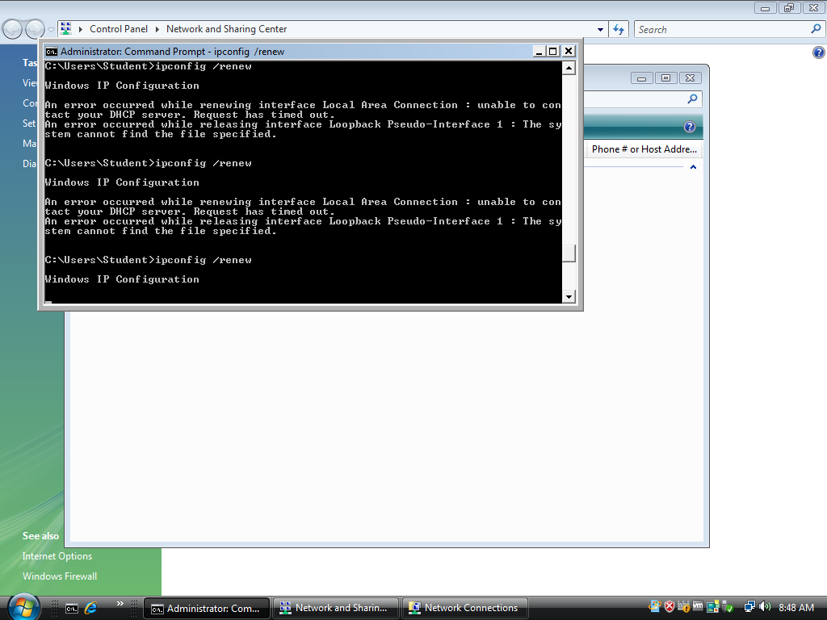

Go back to Host A where Wireshark is running. HOST_A's Wireshark session will capture the DHCPDISCOVER frame from Host B.

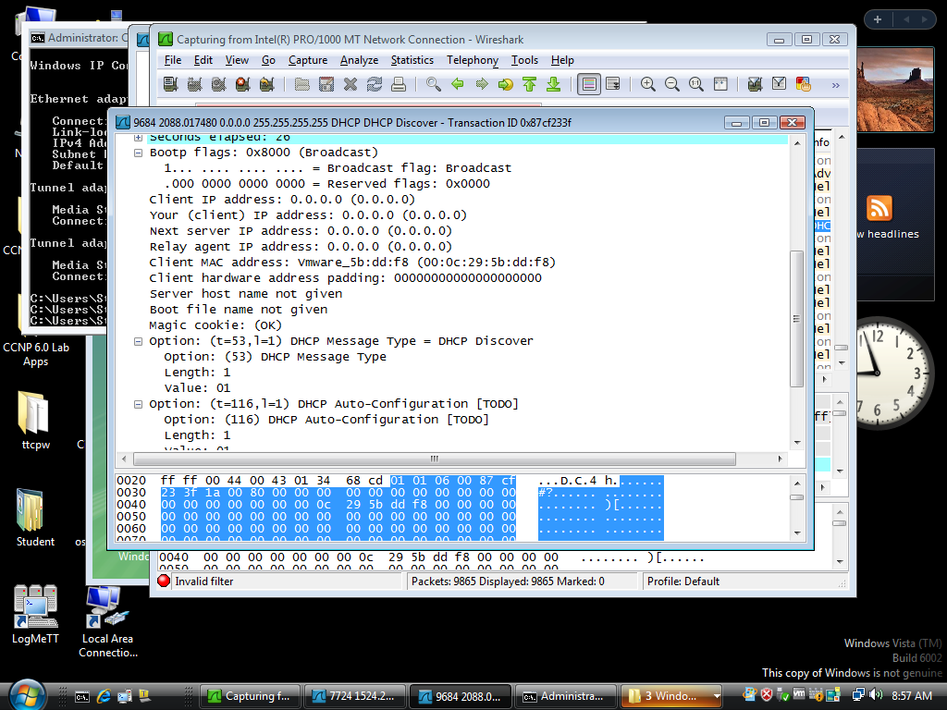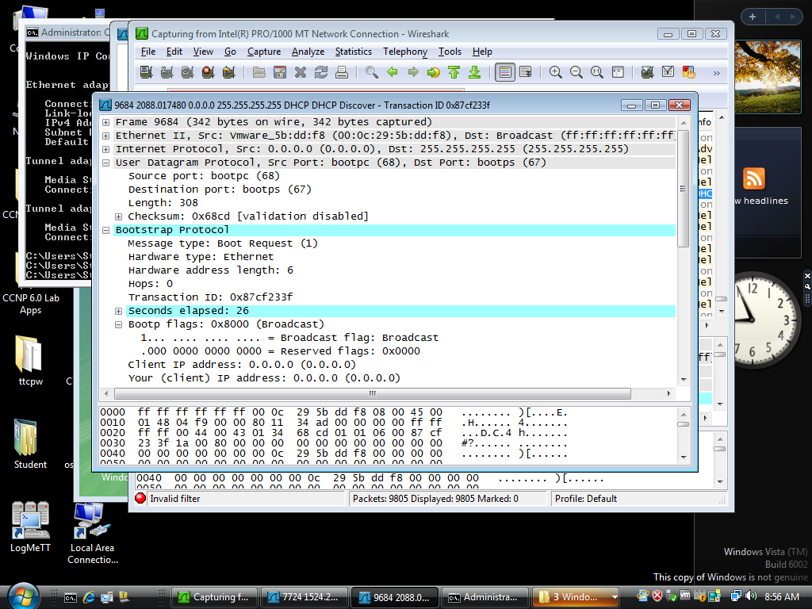.

If Host A were an attacker, the attacker could craft DHCP server OFFER messages or other DHCP sever messgages to respond to Host_B’s DHCP request.

To help protect the network from such an attack, you can use DHCP snooping.

DHCP snooping is a Cisco Catalyst feature that determines which switch ports are allowed to respond to DHCP requests. Ports are identified as trusted or untrusted. Trusted ports permit all DHCP messages, while untrusted ports permit (ingress) DHCP requests only. Trusted ports can host a DHCP server or can be an uplink toward a DHCP server. If a rogue device on an untrusted port attempts to send a DHCP response packet into the network, the port is disabled. From a DHCP snooping perspective, untrusted access ports should not send any DHCP server responses, such as a DHCPOFFER, DHCPACK, or DHCPNAK.

Configure IPv4 DHCP Snooping

1. Enable DLS1 and DLS2 to trust DHCP relay information from ALS1 and ALS2 so that the DHCP server can respond to the ALS1 and ALS2 trusted port requests. This is accomplished using the **ip dhcp relay information trust-all** command.

DLS1(config)# **ip dhcp relay information trust-all**

DLS2(config)# **ip dhcp relay information trust-all**

**Note**: By default switches that relay DHCP requests will insert option-82 information, which can be used for various management functions. When a switch receives a DHCP frame that has option-82 information on an untrusted interface, the frame will be dropped. The **ip dhcp relay information trust-all** command is one way to work around this default behavior. It is not necessary to enable DHCP snooping on the distribution layer switches, although this would allow DLS1 and DLS2 to trust ALS1 and ALS2 as relay agents.

Configure ALS1 and ALS2 to trust DHCP information on the trunk ports only, and limit the rate that requests are received on the access ports. Configuring DHCP snooping on the access layer switches involves the following steps:

* Turn snooping on globally using the ip dhcp snooping command.
* Configure the trusted interfaces with the ip dhcp snooping trust command. By default, all ports are considered untrusted unless statically configured to be trusted.
* Configure a DHCP request rate limit on the user access ports to limit the number of DHCP requests that are allowed per second. This is configured using the ip dhcp snooping limit rate rate_in_pps. This command prevents DHCP starvation attacks by limiting the rate of the DHCP requests on untrusted ports.
* Configure the VLANs that will use DHCP snooping. In this scenario, DHCP snooping will be used on both the student and staff VLANs.

ALS1(config)# **ip dhcp snooping**

ALS1(config)# **interface range fastethernet 0/7 - 12**

ALS1(config-if-range)# **ip dhcp snooping trust**

ALS1(config-if-range)# **exit**

ALS1(config)# **interface range fastethernet 0/6, f0/15 - 24**

ALS1(config-if-range)# **ip dhcp snooping limit rate 5**

ALS1(config-if-range)# **exit**

ALS1(config)# **ip dhcp snooping vlan 100,200**

ALS2(config)# **ip dhcp snooping**

ALS2(config)# **interface range fastethernet 0/7 - 12**

ALS2(config-if-range)# **ip dhcp snooping trust**

ALS2(config-if-range)# **exit**

ALS2(config)# **interface range fastethernet 0/6, f0/15 - 24**

ALS2(config-if-range)# **ip dhcp snooping limit rate 5**

ALS2(config-if-range)# **exit**

ALS2(config)# **ip dhcp snooping vlan 100,200**

1. Verify the configurations on ALS1 and ALS2 using the show ip dhcp snooping command.

ALS2# **show ip dhcp snooping**

Switch DHCP snooping is enabled

DHCP snooping is configured on following VLANs:

100,200

DHCP snooping is operational on following VLANs:

100,200

DHCP snooping is configured on the following L3 Interfaces:

Insertion of option 82 is enabled

circuit-id default format: vlan-mod-port

remote-id: 0017.95cf.1680 (MAC)

Option 82 on untrusted port is not allowed

Verification of hwaddr field is enabled

Verification of giaddr field is enabled

DHCP snooping trust/rate is configured on the following Interfaces:

Interface Trusted Allow option Rate limit (pps)

----------------------- ------- ------------ ----------------

FastEthernet0/6 no no 20

Custom circuit-ids:

FastEthernet0/7 yes yes unlimited

Custom circuit-ids:

FastEthernet0/8 yes yes unlimited

Custom circuit-ids:

Interface Trusted Allow option Rate limit (pps)

----------------------- ------- ------------ ----------------

FastEthernet0/9 yes yes unlimited

Custom circuit-ids:

FastEthernet0/10 yes yes unlimited

Custom circuit-ids:

FastEthernet0/11 yes yes unlimited

Custom circuit-ids:

FastEthernet0/12 yes yes unlimited

Custom circuit-ids:

<...OUTPUT OMITTED...>

Verify IPv4 DHCP Snooping Operation

To verify DHCP Snooping is working, re-run the test conducted to observer DHCP operation without DHCP snooping configured. Ensure WIRESHARK is still running on HOST_A. Issue the ipconfig /renew command on HOST_B. In this case, the DHCPDISCOVER should NOT be seen at HOST_A.

Once validated, change ALS1 f0/6 back to VLAN 100 and make sure HOSTA and HOSTB have valid static IP addresses assigned (HOSTA: 172.16.100.101/24, DFG 172.16.100.1; HOSTB: 172.16.200.101/24, DFG 172.16.200.1).

Will DHCP replies be allowed to ingress access ports assigned to VLAN 200?

No. the access ports assigned to VLAN 200 are untrusted for DHCP snooping. Only DHCP requests can be sent out of these ports, not replies

How many DHCP packets will be allowed on Fast Ethernet 0/16 per second?

It will be limited to 20 packets per second.

Over DHCP limit rate obmedzovač

Použí útok

Yersinia dhcp -attack 1 –interface eth0

Arp inspection a IP source guard

|  |  |  |
| --- | --- | --- |
| **Konfiguruj ARP inspection** | | |
| Pingni z PC default gw, over arp, potom položku zmaž |  |  |
| Spusti ARP spoof na BT | arpspoof [-i interface] [-t target] host  arpspoof -i eth1 -t 172.16.10.2 172.16.10.1 |  |
| Over arp na PC po pingnuti DG. |  |  |
| Konfiguruj ARP inspection pre všetky vlan 100, 150 a 200 | Ip arp inspection vlan 100,150,200 |  |
| Konfiguruj trunk porty ako trust | Int ra fa 0/7-12  ip arp inspection trust | Sh ip arp inspection  sh ip arp inspection statistics |
| **Konfiguruj IP Source guard** | | |
| Konfiguruj na untrusted portoch | ip verify source | show ip source binding  **show ip verify source** |
| Cdp flood | Ukaz na agregator |  |
| Konfigurácia AAA | | |
| Konfiguruj prihlásenie na prepínač voči lokálnej DB | username palo password palo  username jozo password jozo  aaa new-model  aaa authentication login AE_l_local local  line con 0  login authentication AE_l_local | Over prihlásením |

CDP útoky

Útok na zahltenie CDP tabuľky

sudo yersinia cdp -attack 1

Configure AAA

AAA stands for Authentication, Authorization, and Accounting. The authentication portion of AAA is concerned with the user being identified before being allowed access to the network. Authentication is configured by defining a list of methods for authentication and applying that list to specific interfaces. If lists are not defined, a default list is used.

For this network, it has been decided that AAA will be used for to validate users attempting to log into the VTY lines of our network devices. For this lab, the AAA server will be a radius server on Host C (172.16.99.50) connected to DLS1's F0/6 interface. There are many different radius server alternatives, but for this the program WinRadius will provide the radius function and host the username/password database.

Konfigurácia winRadius je v Appendixe A.

Configure Switches to use AAA to secure VTY line access

As it stands, all of the switches should have a statically assigned password of cisco on the VTY lines. This is not a scalable configuration. It requires a single known password, and manual modification of each switch individually as well as controlled dissemination of that single known password. Using centralized authentication is a much simpler method, where each user uses their own unique username and password.

Configure PC-C to with the 172.16.99.50 with a default-gateway of 172.16.99.1. Ensure that PC-C has connectivity to the gateway and all four switches.

Make the following configuration changes to all four switches:

* + 1. Issue the aaa new-model global configuration command to enable AAA

ALS1(config)# aaa new-model

* + 1. Configure a local user named lastditch with a privilege level of 15 and a password of $cisco123&

ALS1(config)# user lastditch privilege 15 password $cisco&

* + 1. Configure the radius server to use authentication port 1812, accounting port 1813 and the shared key WinRadius

ALS1(config)# radius server RADIUS

ALS1(config-radius-server)# address ipv4 172.16.99.50 auth-port 1812 acct-port 1813

ALS1(config-radius-server)# key WinRadius

ALS1(config-radius-server)# exit

ALS1(config)#

* + 1. Configure the AAA authentication method REMOTE-CONTROL to use the radius server and to fallback to the local database

ALS1(config)# aaa authentication login REMOTE-CONTROL group radius local

* + 1. Configure the VTY lines to use the REMOTE-CONTROL authentication method

ALS1(config)# line vty 0 4

ALS1(config-line)# login authentication REMOTE-CONTROL

ALS1(config-line)# exit

Configure WinRadius

Use the instructions in Appendix A to setup, test, and run WinRadius. As a part of the configuration, you should have the user account remote with the password cisco123.

**Pozn**. Pôjde aj voči lokalnej DB

**Test centralized VTY line authentication**

Now from a host on the network, attempt to telnet to one of the switches. You should be required to enter a username and password . Use the username of *remote* and the password of cisco123. Authentication should be successful.

Shutdown unused port and move them to a Parking Lot

As an added layer of security to our campus architecture, ensure that all unused ports are configured as static access ports, shutdown and moved away from VLAN 1 to an unused VLAN named Parking_Lot. Verify that the ports are unused because applying this configuration to trunk ports will adversely affect layer 2 connectivity.

Also, add another protective measure by suspending the state of the parking lot VLAN.

Repeat the below configuration on all unused switch ports on ALL switches.

ALS1(config)# **interface range fa0/1 – 5, f0/14-16, gi0/1-2**

ALS1(config-if-range)# **switchport mode access**

ALS1(config-if-range)# **switchport access vlan 999**

ALS1(config-if-range)# **shutdown**

ALS1(config)# **vlan 999**

ALS1(config-vlan)# **state suspend**

**Note**: Save your final device configurations for use with the next lab.

**Appendix A—WinRadius Server Installation**

**Note:** A WinRadius (or comparable) server should be installed on server SRV1 for this lab. If it is not, you can use the following procedure to download and install it. Check with your instructor if you have questions regarding the RADIUS server installation.

Link na download: <http://winradius.eu/Download.html>

**Step 1: Download the WinRadius software.**

A number of RADIUS servers are available, both freeware and for sale. This lab uses WinRadius, a freeware standards-based RADIUS server that runs on Windows 7 and most other Windows operating systems.

**Note:** The free version of the software can support only five usernames.

**Step 2: Install the WinRadius software.**

a. Create a folder named WinRadius on your desktop or other location in which to store the files.

b. Search the web for **winradius** and download the latest version from a trusted website.

**Instructor note:** The instructions provided in this lab are for WinRadius 4.0. However, you can use another RADIUS server if one is available.

c. Save the downloaded zip file in the folder created in Step 2a, and extract the zipped files to the same folder. There is no installation setup. The extracted WinRadius.exe file is executable.

d. You can create a shortcut on your desktop for WinRadius.exe.

**Step 3: Configure the WinRadius server database.**

a. Start the WinRadius.exe application. WinRadius uses a local database in which it stores user information. When the application is started for the first time, the following messages are displayed:

Please go to “Settings/Database and create the ODBC for your RADIUS database.

Launch ODBC failed.

b. From the main menu, select **Settings > Database**.

c. Click the **Configure ODBC automatically** button and then click **OK**. You should see a message that the ODBC was created successfully. Exit WinRadius and restart the application for the changes to take effect.



d. When WinRadius starts again, you should see messages similar to the following:



**Instructor note:** WinRadius listens for authentication on port 1812 and accounting on port 1813.

**Step 4: Configure users and passwords on the WinRadius server.**

**Note:** The free version of WinRadius can support only five usernames at a time. The usernames are lost if you exit the application and restart it. Any usernames created in previous sessions must be recreated. The first message in the previous screen shows that zero users were loaded. No users had been created prior to this, but this message is displayed each time WinRadius is started, regardless of whether users were created or not.

a. From the main menu, select **Operation > Add User.**

b. Enter the username **remote** with a password of **cisco123.**

c. Click **OK**. You should see a message on the log screen that the user was added successfully.

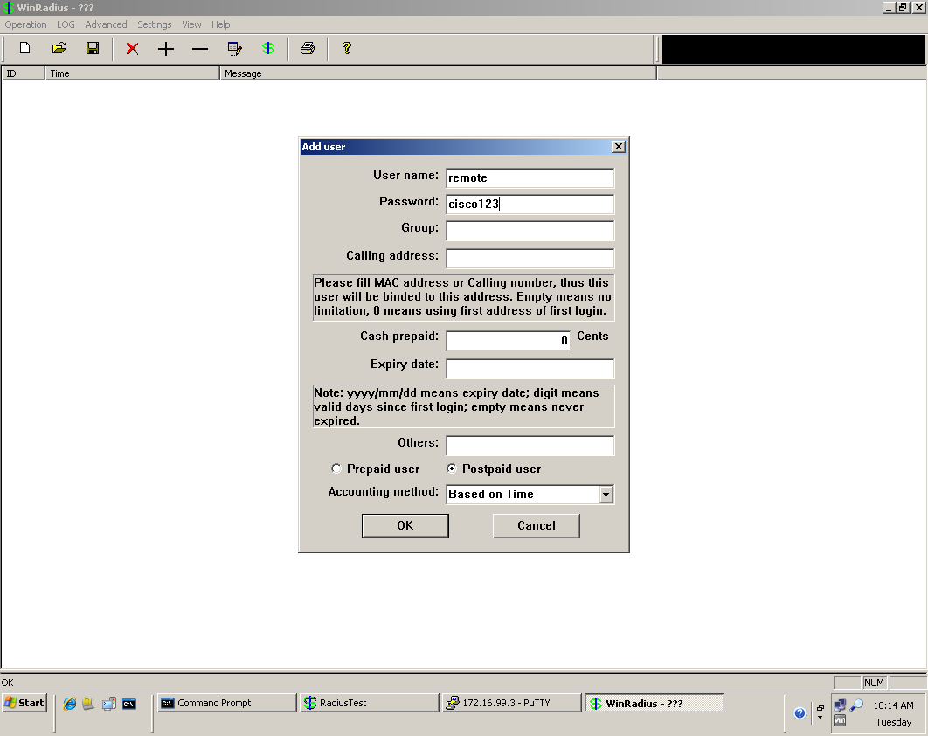

**Step 5: Clear the log display.**

From the main menu, select **Log > Clear**.

**Step 6: Test the new user added using the WinRadius test utility.**

a. A WinRadius testing utility is included in the downloaded zip file. Navigate to the folder where you unzipped the WinRadius.zip file and locate the file named RadiusTest.exe.

b. Start the RadiusTest application, and enter the IP address of the RADIUS server. For this lab, the RADIUS server is SRV1, and the IP address is 172.16.99.50.

c. Enter username **remote** and password cisco123. Do not change the default RADIUS port number of 1813 nor the RADIUS password of WinRadius.

**Note:** Be sure to use the IP address of PC-C in this lab (172.16.99.50) when testing.

d. Click **Send** and you should see a Send Access_Request message indicating that the server at 172.16.99.50, port number 1813, received 44 hexadecimal characters. On the WinRadius log display, you should also see a message indicating that user *remote* was authenticated successfully.

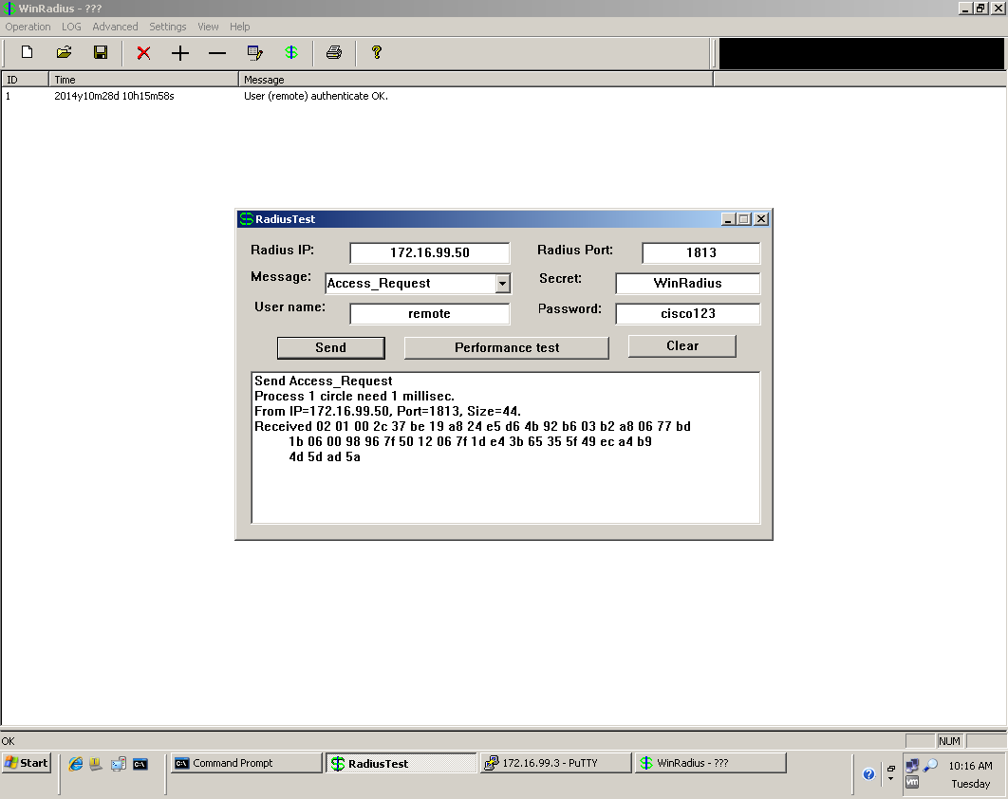

e. Close the RadiusTest application.